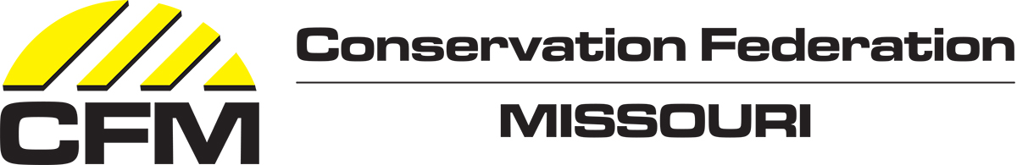
David Risberg Memorial Grant Application
This application is designed to be as easy to complete as possible. Please keep responses brief and to the point. Proposals should be relevant to the shared mission of the Affiliate and CFM and the criteria identified in the grant program guidelines. For 2020, CFM will be awarding a total of $10,000 in grants.
The deadline for applications is December 31, 2019.
Contact Information and Eligibility

Contact information*
Organization Name:
First Name:
Last Name:
Position/Title:
Address:
City:
State:
Zip:
Email:
Phone#:
Are you the leader for this project? ☐ Yes☐ No

Additional Contact Information
Include any additional contact information for other project participants here (if relevant).

If awarded this grant, you will be required to provide a description of the project for presentation at the 2020 CFM Affiliate Summit and a PowerPoint presentation (2-3 slides) of your project to be displayed at the 2021 CFM Annual Meeting. Posters will be due no later than February 28, 2021. Are you able to commit to this? * ☐ Yes ☐ No

Project Title*
Provide a short, descriptive title for the project or program you are proposing.

Project Description
Project Location*
Give a description of the area that the project would take place.

Project Participants*
How would you describe the community of people who will benefit from your project? How will they contribute to the project?

Description of your project and how it promotes conservation. *Briefly describe your project proposal. Provide estimated number of volunteer hours for the project, if applicable. Are you a membership organization? If so, how many members do you have, and will only your members be involved or also members of the public?

Goals and Objectives*
Briefly describe the project’s goals and objectives.

Timeline*
Provide a brief timeline for starting and completing the project.

Will your project begin after February 28, 2020? * ☐ Yes ☐ No

Will your project end before March 1, 2021? *
☐ Yes
☐ No
☐ This is an ongoing project but funds will be used by March 1.
Projects must be completed before March 1, 2021 unless the project is ongoing, in which case grant funds must be used by March 1, 2021.

Briefly describe the project’s measurable outcomes. *
For example: number of people participating in the project, the total number of hours worked, the research results generated, and/or the size of the habitat to be restored.

Briefly describe how your project ties in with the mission of CFM and your organization. *
Connection to CFM/Affiliate vision, mission and values

Finances and Budget
What is your organization’s annual operating budget? *
$

Funding request – Amount*
How much funding are you requesting for this project?
$

Would partial funding be accepted? ☐ Yes ☐ No

Project Budget – include as much information as is available*
Include or attach an itemized budget for the project that indicates the sources and uses of funds. (Include values for matching funds and in-kind contributions.) Please indicate above whether partial grant funding would be acceptable.

Who are your partners for this project?
List any partner organizations and describe the contribution (financial, in-kind or volunteers) of each partner to the project. Do not include paid contractors as partners unless the services are donated.

Who is the Fiscal Agent and signature authority for this grant? Provide all contact info.
Organization Name:
First Name:
Last Name:
Position/Title:
Address:
City:
State:
Zip:
Email:
Phone#:
Is this person the fiscal agent? ☐ Yes ☐ No
Provide your 9-digit Federal Tax ID Number. *
If you are working with a fiscal agent, provide their number.

Indicate if you are providing any of the attachments below. *
☐ 1-2 photographs that capture the project, plan or group involved in the proposal – REQUIRED
☐ Letter of partner commitment – OPTIONAL
If applicable, attach a letter of partner commitment – OPTIONAL

Insert pics here

